Computational Creativity COMP6590 Final Project Report:

AI Generated Jewellery using a Generative Adversarial Network

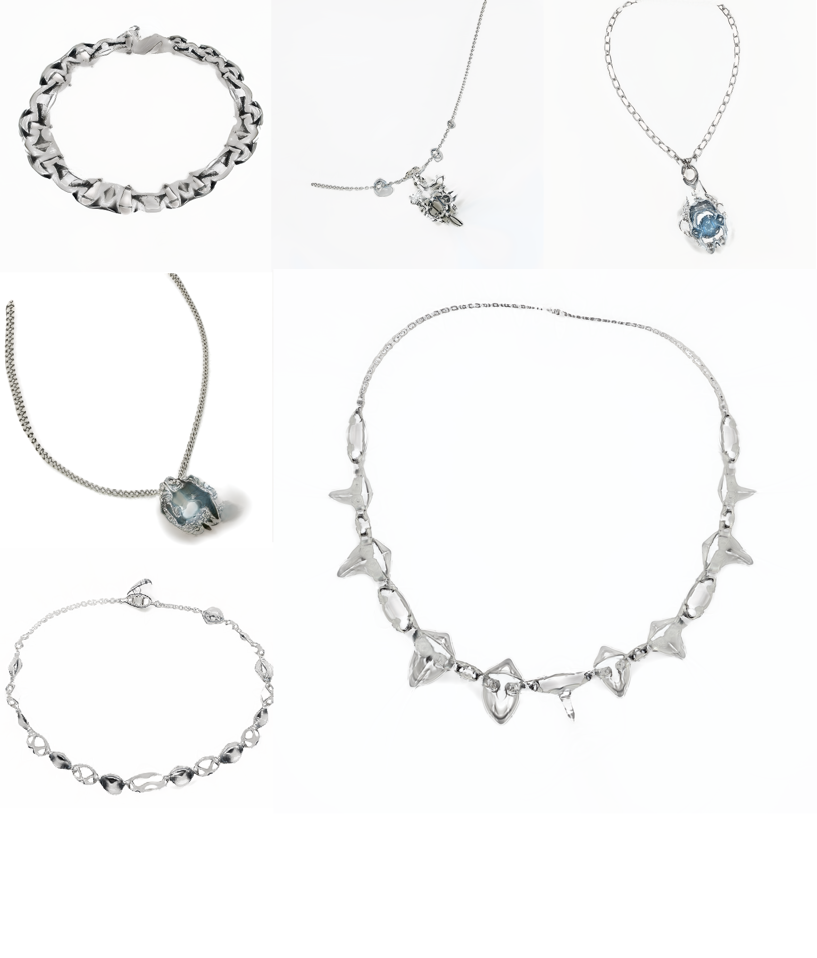

Abstract

This report presents the development and evaluation of an AI Jewellery Generator using a Generative Adversarial Network (GAN), StyleGAN3. The project aims to create a diverse and high-quality set of jewellery designs by feeding a diverse range of existing unique designs into a GAN and generating innovative ideas to spark creativity for the user.

The report covers the related works, methodology and design, implementation, results, evaluation, and conclusions drawn from the project.

Introduction

Although the demand for unique and aesthetically pleasing jewellery designs has always been high in the fashion industry in recent years, the creativity of recent fashion items has seen very slow progress, where designers rely on trial-and-error or pre-existing ideas to find the next innovative design. With the advent of AI, there is potential for automating and generating intricate and creative designs, which could change the fashion scene.

The model uses a pre-trained model from StyleGAN3 by NVIDIA[1], which was trained on a dataset of 70,000 of different faces[2] and is provided a custom dataset of manually picked images (1024x1024 pixels) of accessories from various sources such as luxury boutiques, pinterest, and other e-commerce stores. The pre-trained model provided has learnt various features from its previous computationally expensive training undergone by NVIDIA, and can translate its training to pick up distinct features of jewellery.

Background

Currently there are already a lot of existing applications of GANs applied on various different things. The AI Jewellery Generator project is inspired by and built upon research that will be presented below, and their applications in art and design.

Art and design

The application of GANs in art and design has been demonstrated from many individual projects done online, and one of them is StyleGAN3 and Anime Faces[3]. StyleGAN3, the latest version of the StyleGAN series, has been successfully applied to generate various anime faces and art. The impressive results in generating anime faces demonstrate the potential of StyleGAN3 in generating complex designs. The blog inspired the creation of the Jewellery generator as there is very little information of AI being used for fashion garments online.

Research

Generative Adversarial Networks (GANs):

GANs, introduced by Goodfellow et al. (2014)[4], are a class of deep learning models that consist of two neural networks: a generator and a discriminator. The generator creates new data instances, while the discriminator evaluates their authenticity. This adversarial process leads to the generation of high-quality synthetic data. A variety of YouTube videos[5] on GAN implementation have provided valuable insights into the components of GANs, such as latent vectors, discriminators, generators, and training loops, which have informed the development of the AI Jewellery Generator project[6].

StyleGAN2-ADA, an adaptive version of StyleGAN2, is designed for faster training and requires fewer images for the dataset[7]. This model improves upon the original StyleGAN2 by addressing training stability and data efficiency issues. As this version of StyleGAN was developed years back, incompatibility issues occurred on the development of this project as previous versions of PyTorch and CUDA were inaccessible, which led to StyleGAN3 being used.

Methodology and Design

Model

The finished model was a modified version of the StyleGAN3 implementation using Python Jupyter, Torch 1.13.1 and CUDA. Most of the network was already pre-built so most of the work was dedicated towards processing the dataset, fine-tuning the training, and regulating the generated images for the best results. The steps of customising the StyleGAN3 was straight-forward as the Github explains all the code, and what specific parameters and files do.

Pre-processing the dataset required the images to be a certain format, which the resolution must be in powers of 2 (256x256, 512x512), and 1024x1024 was chosen as for jewellery designs, high-quality and mesmerising photos are more desired to capture the viewer's attention, which would also cost more computational power.

The manually picked images were run through python code to pad and resize the images if they were not in the correct resolution. Initially the first iteration had 40 images, which led to overfitting of the model as most of the designs were similar, which eventually led to manually picking up to 500 more unique designs for the finished product.

The resized images were run through LANCZOS anti-aliasing from the PILLOW library in python to maintain its quality, and converted to RGB format with the file type being .png to maintain consistency. Then, the dataset is run through the dataset_tool.py file within the StyleGAN3 implementation, which generates a .json file and the processed images.

After the dataset has been processed, the training can finally be initiated with the training.py file.

Training and Generated Results

The majority of training was used with 4x RTX 3090s on a dataset of 500 images. Additionally, the augmentation parameter (--aug) was set to ada, which increased the dataset size to 1000 as the goal of augmentation is to increase the variety in the dataset by experimenting with orientation, colour, etc. of the current dataset[8].

The gamma parameter (--gamma) was the most experimented during training of the model as the increasing the value could allow the network to generate more creative designs. The default value recommended by NVIDIA for a 1024x1024 dataset and training under a StyleGAN3-t config is a value of 32[9]. As training and inspecting the generated pictures went along, various gamma values were used, which were 0.9, 64, and 96.

Initially, training the StyleGAN3 was off to a rough start as the starting point of the dataset was approximately 40 images, and the training did not use a pre-trained network snapshot, which meant the network had to train from scratch. The network eventually broke as the generated images did not resemble anything since the dataset was small, and the network most likely picked up on the wrong features to learn from (Figure 1).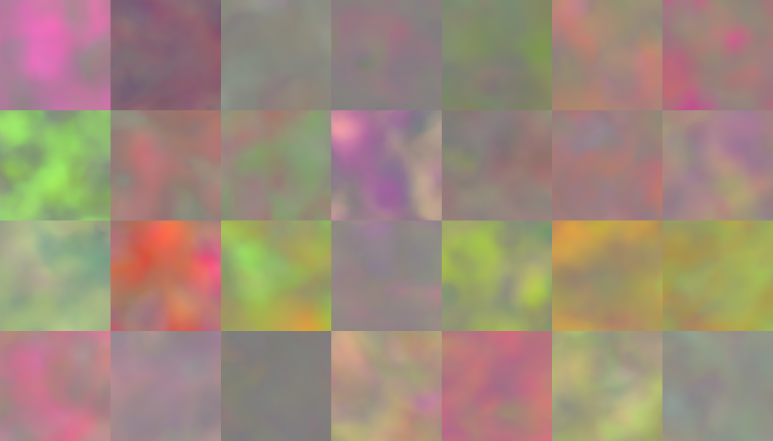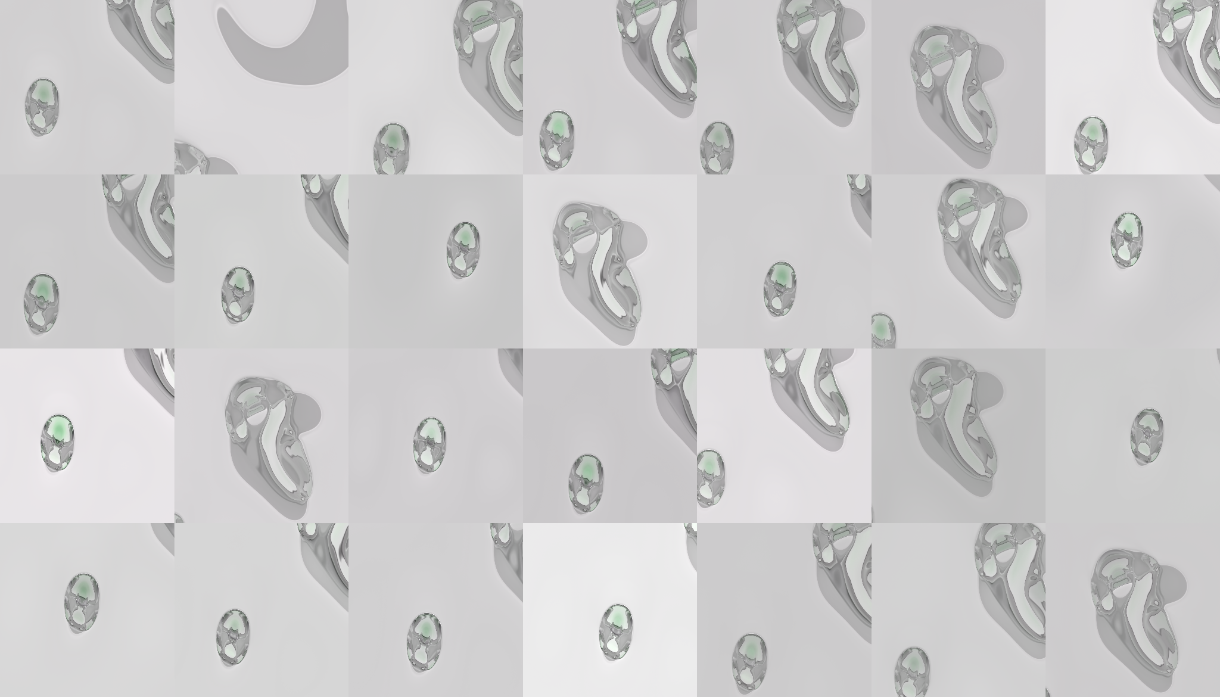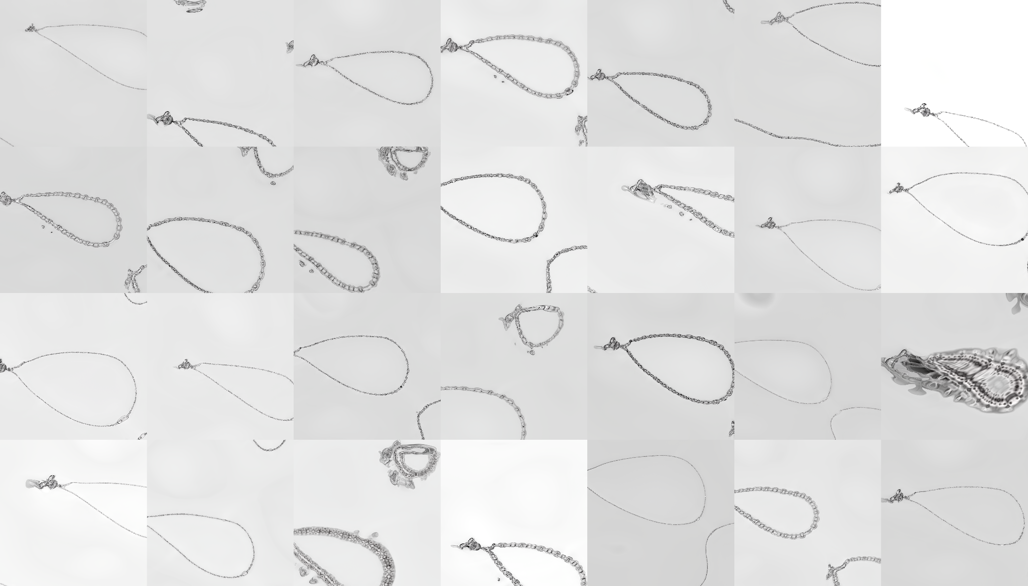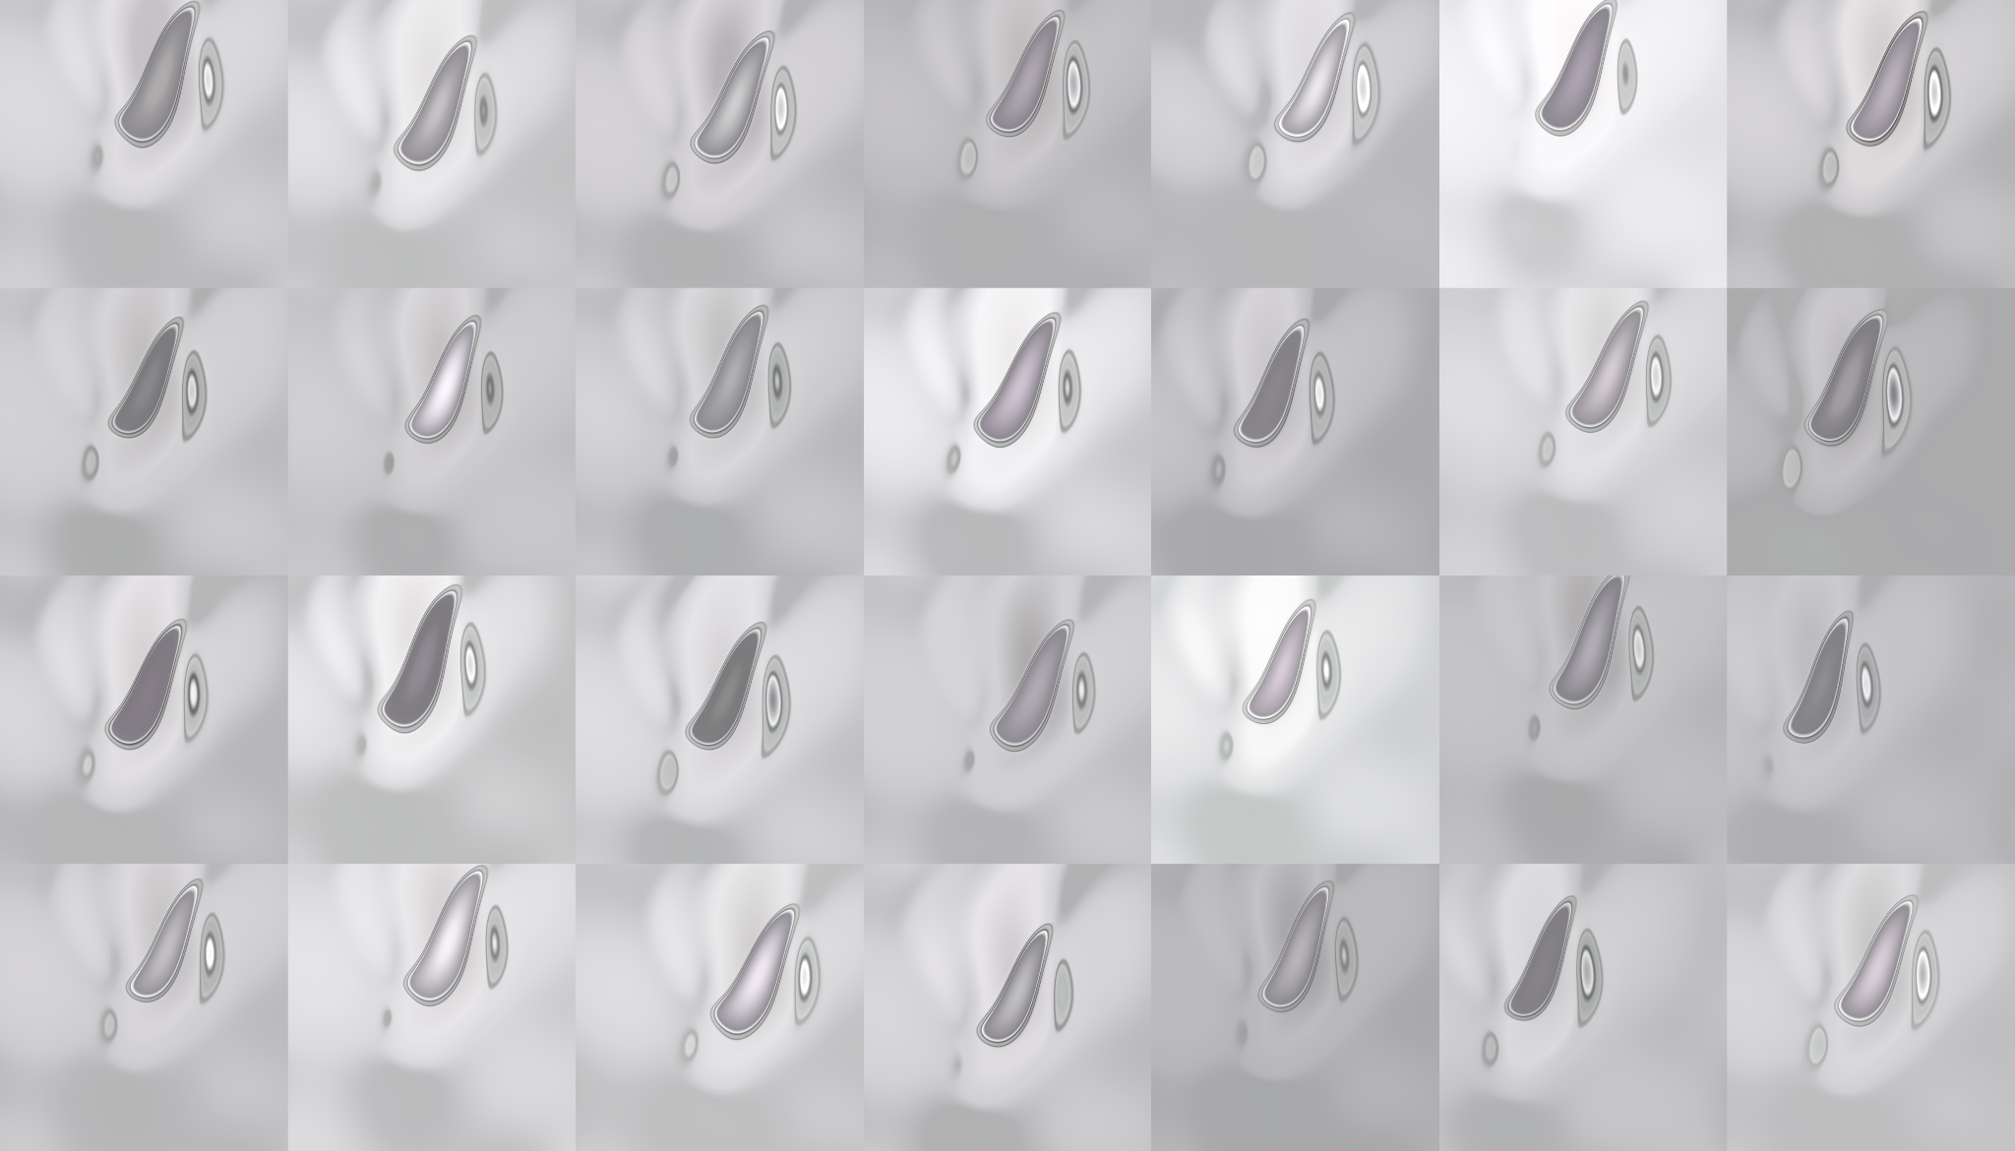

Figure 1. Around 100 ticks from training the StyleGAN3 from scratch produced distorted features from

the fakes generated after each checkpoint of training.

As the training produced more abstract art than jewellery designs, the first iteration was stopped and 300 manually-picked images were added to the dataset, and a pretrained model which was trained on FFHQ faces replaced the current one, which led to significantly faster training speeds and better results compared to training from scratch. The choice of using the FFHQ pre-trained model was unexpected as it seemed there would be no translation from being trained on faces to jewellery, which the results proved otherwise.

Using the pre-trained model required downloading the network snapshot and using the resume (--resume) parameter to start training the network. The generated pictures at the initial ticks resembled the faces used from training human faces but after a couple ticks, the network quickly generated jewellery.

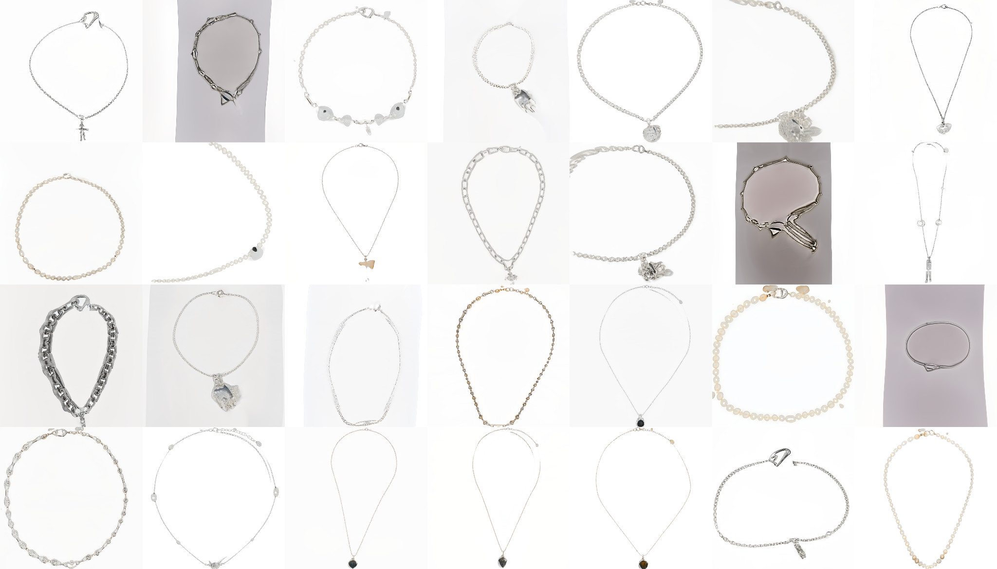

Figure 2. Around 50 ticks, the pre-trained model generated identifiable necklaces.

After training the model for around 2 days, the generated pictures resembled jewellery, which the results were aesthetically pleasing but incomplete as the results seemed still too conventional. An additional 200 images, which were specifically more unique than the ones in the dataset were added to the dataset to provide more variety.

At the 5 day mark, the model has been trained up to 400 ticks and successfully produces innovative designs, although some of the designs seem like a variation of the ones in the dataset (Figure 3).

For generating the pictures, the gen_images.py must be used with a seed parameter (--seed), where the model produces random samples off the value of the seed. So when you insert seed 1, the same exact image will always be shown. So for the user, we must generate a random seed in order to give the user a satisfactory experience in generating jewellery. The truncation parameter (--trunc) is also used between a value 0 to 2 and determines how experimental the AI will be in generating pictures.

However, there is a problem as generating from python still requires a high-end GPU as the gen_images.py file uses the network snapshot that is the output of training our AI. So the solution is to pre-generate the pictures for the user and create a simple website where the user can click a button to generate the image.

The gen_images.py file has been modified to include a random number generator between the seeds 1 to 100,000, and generates around 1000 images for the user to navigate through. The final product consists of 5000 x 4 generated images with randomised seeds from manually-picked out network snapshots of the most aesthetic pleasing models judged from the pictures it produced.

Lastly, a simple website is created with a ‘creativity’ slider that would navigate between folders 1-4, which each folder had varying truncation values and a different network snapshot. As the truncation value was at 0.5, it would create images where the quality was high, but less experimental. On the other hand, with value 2, the images would get blurred and look more abstract than practical pieces of jewellery.

Figure 3. Around 400 ticks, the model produces unique necklaces with varying chains and pendants.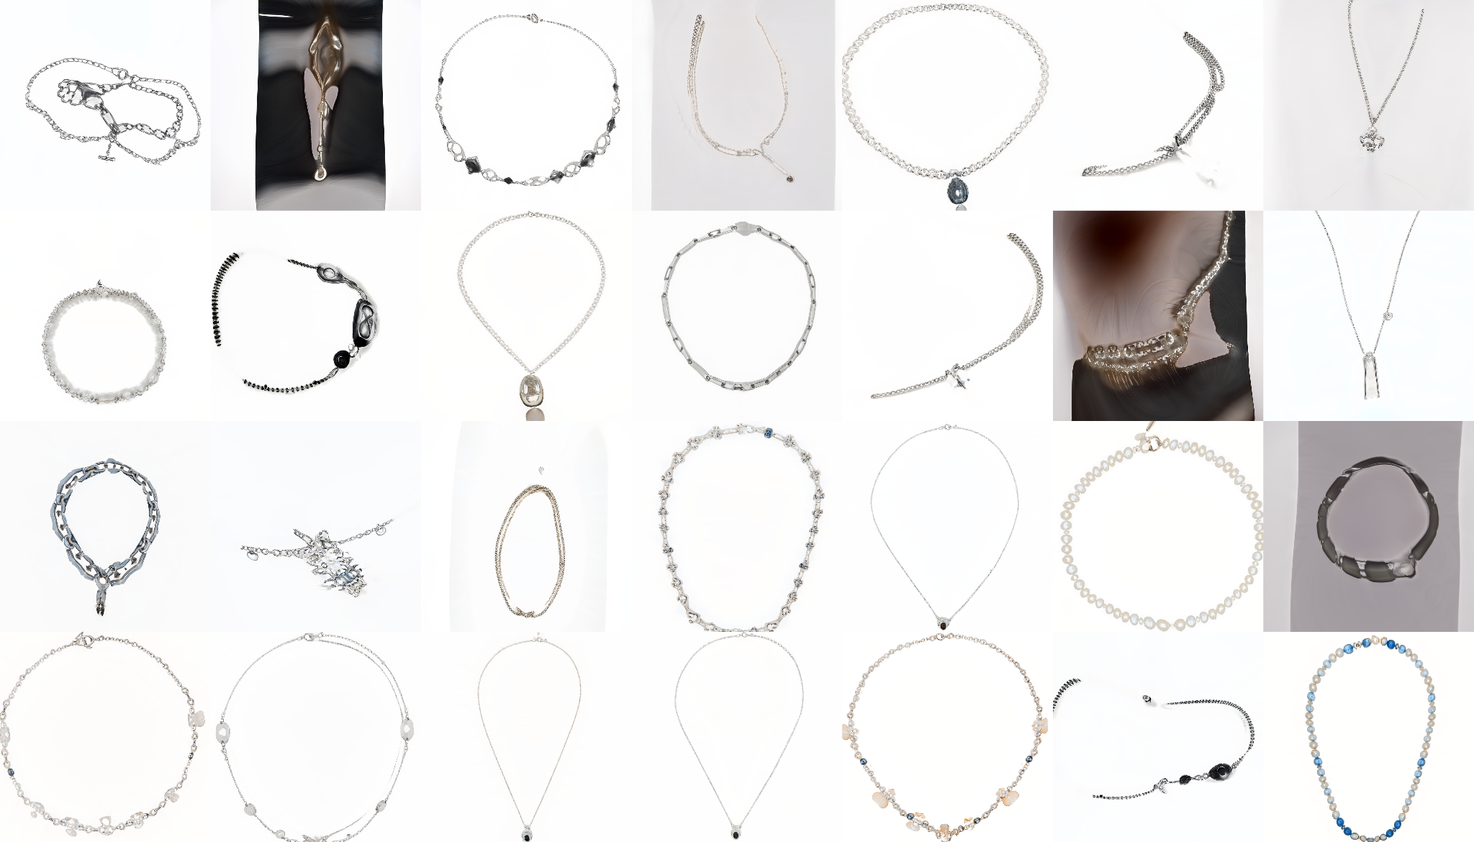

Evaluation

Quality

Looking at the results, we can see that the pieces generated are passable as stock pictures for e-commerce websites. However, there are some noticeable artefacts generated by the GAN, such as the blurring of the pendant itself. For example in Figure 3, the 2nd pendant is visibly blurred compared to the rest of the generated images.

As this model was only trained briefly with around 400 ticks and finished models are generally 6000-7000 ticks, the generation can be improved.

Creativity

The creativity was measured with a survey including 5 friends where all are decently knowledgeable with jewellery. The generated pictures were shown and they would give their feedback. The feedback received was positive, saying that it does have the potential to spark ideas, and they have even come up with their own ideas from these images.

Measuring creativity was rather a straightforward approach and should be improved with a larger audience.

Skill

The model clearly demonstrates skill as it is able to create some fascinating results even with the resolution at 1024x1024.

Imagination

Since the GAN follows no procedure in how to generate jewellery, it could be argued that the system is really truly creative as the system gets trained on a specific dataset provided and can never truly deviate from the established form.

Conclusion

The system succeeds in generating high quality unique pieces of jewellery however, there are a lot of improvements to be done.

The overall creativity of the generated pictures resembled a variation of pieces in the dataset. The project has succeeded in helping users spark ideas, but the ultimate goal is to create designs that both deviate from and draw inspiration from pre-existing designs.

An interesting idea is that the most voted creative images generated by the model could be returned into the dataset, introducing a growing dataset of more creative designs, which will be experimented in future.

1. Official PyTorch implementation of StyleGAN3 - https://github.com/NVlabs/stylegan3
2. Flickr-Faces-HQ Dataset (FFHQ) - https://github.com/NVlabs/ffhq-dataset
3. Training StyleGAN3 on Anime Faces - https://blog.runpod.io/training-stylegan3-on-runpod/
4. Generative Adversarial Networks - <https://dl.acm.org/doi/pdf/10.1145/3422622>
5. StyleGAN2 Implementation - https://youtu.be/73rZhFVmlS8
6. Building a GAN from Scratch on Fashion MNIST set - https://youtu.be/AALBGpLbj6Q
7. StyleGAN2-ada - https://github.com/NVlabs/stylegan2-ada
8. Augmentation.py Stylegan3 - https://medium.com/@Dok11/how-to-check-augmentations-for-the-stylegan3-196f8c2ddf07
9. Recommended training configurations - https://github.com/NVlabs/stylegan3/blob/main/docs/configs.md